Isabel Karambelas 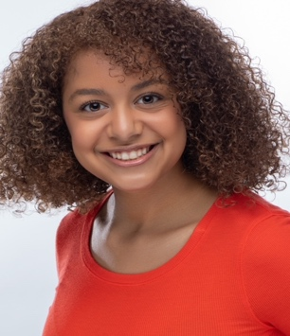

Kids international Agency
938 E. Swan Creek Road, Suite 152
Fort Washington, MD 20744
Phone Number: 301.292.6094
Fax Number: 301.292.7965

Age Range: 13– 16 Years old
Hair Color: Brown
Eye Color: Light Brown
Height: 5 ft. 0 in.
Weight: 115 lbs.
TRAINING:
Master Class: Cold Reading Kids International Ms. Hanna
Audition techniques
Modeling/Finishing Barbizon Model Ms. China
17th Annual Barbizon Capitol Competition Mark Center Model/Acting
18th Annual Barbizon Capitol Competition Mark Center Model/Acting
PTD Model & Talent Overall Winner PTD Cruise Improv/Acting
TelePrompter / Acting Workshop Kids International Ms. Homer
Hip Hop (Intermediate) Born To Dance Ms. Agenor
Jazz Dance Audrey Moore Rec Center

LIVE PERFORMANCES:
Commercial Children’s Deodorant News Watch TV Actor
Commercial National’s Baseball Viva Creative Actor
Wiley Publishing HZDG Actor
Commercial AARP (2018) AARP Studios Lead
Commercial Retail (Furniture) Bright Ideas Studios Lead Child
Theater Sports (Improv) Frost Middle School Multiple Roles
Box (play) Frost Middle School Multiple Roles
A Midsummer Night’s Dream Camelot Auditorium Titania
The Lion King Camelot Auditorium Simba
Peter Pan James Lee Cmty. Center Tinkerbell
60’s Musical WFES Auditorium MC/Dancer
Food Wars Play James Lee Cmty. Center Carrot
Disney Princesses HS Musical James Lee Cmty. Center Jasmine
Three Little Pigs WFES Auditorium Brick-house Pig
School Fashion Show WFES Auditorium Model
Mystics Game Capital One Arena Half-time Dancer

Highly disciplined. Takes direction well. Outstanding vocabulary. Excellent memorization skills. Very well spoken, articulate. Hip hop and jazz dance – three years. Gymnastics team – three years, Travel Soccer – four years. Advanced placement (AP) classes.

