**Jacqueline Love Klugh**  
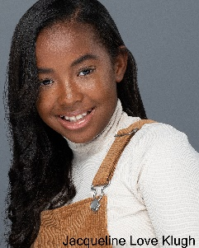

Kids International Talent Agency

938 E. Swan Creek Road, Suite 152

Fort Washington, MD 20744  
PH: 301-292-6094

FX: 301-292-7965

Birthdate: April 23, 2009

Hair Color: Dark Brown

Eye Color: Dark Brown

Height: 5’4”

Weight: 125 pounds

**Print and Video:**

Clarksburg Premium Outlets Awareness Campaign - May 2019 - Extra

Print Ad & Commercial

**Live Performances:**

“High School Musical, Jr.” – Howard County Center for the Arts – Jackie the Announcer

“The Aristocats Kids” - St. John’s Parish Day School Auditorium - Thomas O’Malley

“Joseph and the Amazing Technicolor Dreamcoat” - Howard High School Auditorium – Chorus

“My Favorite Things” - Maryland Music Academy - Voice Solo

“Junie B Jones Musical” - St. John’s Parish Day School Auditorium - Cast Member

“Elf Jr. The Musical” - St. John’s Parish Day School Auditorium – Store Manager

“Legally Blond Jr. The Musical” – Howard Community College – Kiki

**Training:**

Pilot Season Prep 2019 & 2020 Kids International Julia Tasheva/Stephen Shetler

“Creative Use of the Teleprompter” Kids International Stephen Shetler

Voice Lessons Maryland Music Academy Shanna Balman

“Broadway Prep” Columbia Center for Theatrical Arts Gerald Jordan

Piano Lessons Capriccio Studio Francelia McKindra

Tap Dance Lessons Kinetics Dance Theatre Leah Dorsey

Extremely focused and takes direction well; inquisitive; very social; great memorization skills; Loves singing and dancing; Violin – 4 years; swim team (Most Improved Award) – 3 years; Plays in competitive volleyball club league; Enjoys biking, high ropes, climbing, skateboarding, basketball and spending time with animals.