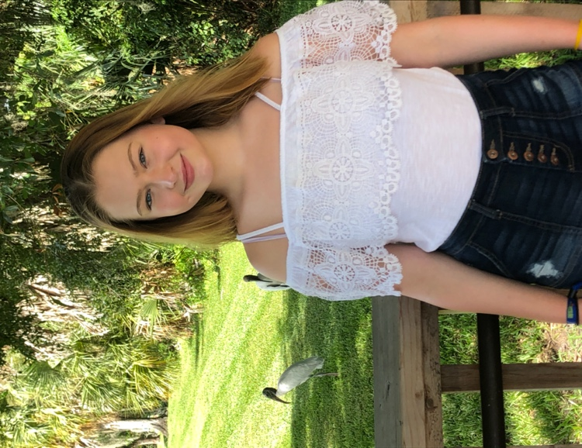 Chelsea Cashin

chelseacashin3000@icloud.com / kccashin5@gmail.com

**HEIGHT**: 5’6” **HAIR**: Light Brown

**BUST**: 36” **EYE**: Blue

**WAIST**: 29” **SHOE**: 8-½

**HIPS**: 38” **AGE**: 15

**TRAINING**: **SKILLS and INTERESTS**:

Barbizon Passport To Discovery Competitor Volleyball

August, 2021 – Orlando, Florida Lacrosse

* Runway Tennis
* TV Commercial Basketball
* Swimwear Theater Tech / Hair / Makeup / Costume
* Jeans Swimming
* Monologue Yoga / Pilates
* Cold Read Modeling
* Improv 101 Shooting

Girl Scouts USA, 10 years

Capitol Barbizon Competition Competitor:

June, 2021 – Baltimore, Maryland

* 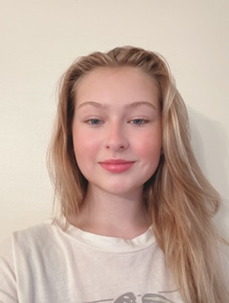Runway
* TV Commercial

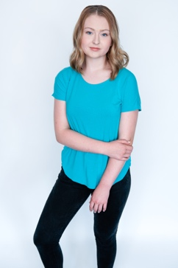Barbizon USA Graduate:

June – November, 2019 – Maryland and Virginia

**EXPERIENCE**:

October, 2021

Fashion for a Cause Charity Fashion Show

Devens, Massachusetts

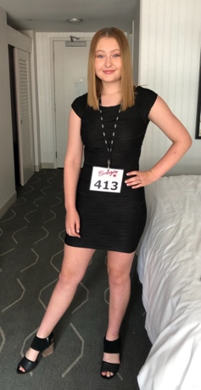Runway Fashion Modelling

July, 2019

Suffield Players, Inc. Theater Camp · Suffield, Connecticut

*Mary Poppins Jr.* Role: Ms. Andrew

May, 2019

Frost Middle School · Fairfax, Virginia

*Once Upon a Mattress Jr.* Role: Tech, Makeup, Hair and Costume Director

December, 2018

Frost Middle School · Fairfax, Virginia

*A Night of One Acts / Box & Help Desk* Role: Tech, Makeup, Hair and Costume